**Introduction**

On February 20, 2020, the first reported death due to COVID-19 in South Korea was occurred in Daenam Hospital, a psychiatric hospital located in Cheongdo-gun. The outbreak of the epidemic in the hospital had a devastating impact, recorded 103 cases of infection out of 103 inpatients. What was worse, most of the psychiatric hospitals that had been exposed to COVID-19 had similar problems, recording 6% of fatality, which is considered to be 1% in general.

The experts pointed out that there are various reasons making psychiatric hospitals more vulnerable to infectious diseases than any other facilities, such as a system that encourages group life, and the condition of inpatients with weak immunity. Due to this reason, they need NPUs more than anyone. However, there are no NPUs that are carefully designed for patients with mental weaknesses. They are more sensitive than ordinary people and are commonly exposed to the danger of experiencing the deterioration of mental state in a changed environment. As we carry out the project, we look over the existing NPU and examine the characteristics of the users, in order to revise the NPUs, especially for mentally-disordered people.

**I. Problem Statement**

Our group assumed that the existing NPUs have limitations in treating patients with mental illnesses, since the units are particularly designed for preventing the spread of infectious diseases. The problem that we observed is that deterioration of mental state due to a sense of isolation is common among mentally disordered patients in NPUs and this makes the medical staffs to pay attention to a psychotherapy as well as treatments for COVID-19. Thus, our goal is to find an effective way to soothe the deterioration of emotional instability caused by quarantine, allowing both medical staffs and patients to focus fully on the COVID-19 treatments.

**II. Background Information of the Project**

As part of the treatment,

**III. Design Plan**

**A. WBS(Work Breakdown Structure), PCM(Percent Complete Matrix) and Gant chart**

i) WBS

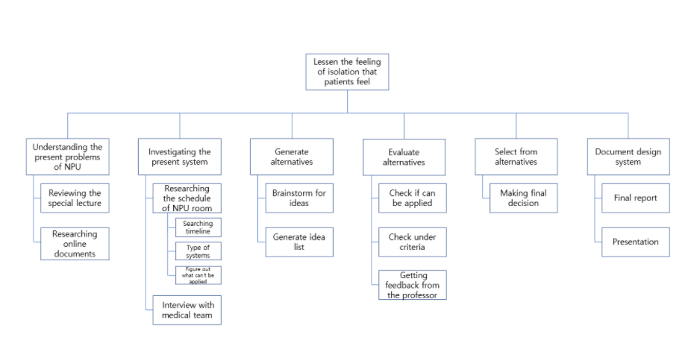

ii) PCM

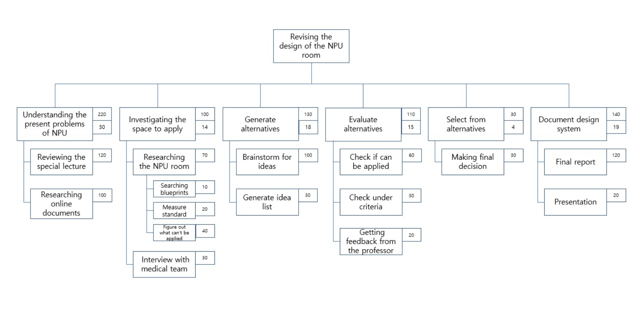

iii) Gant chart

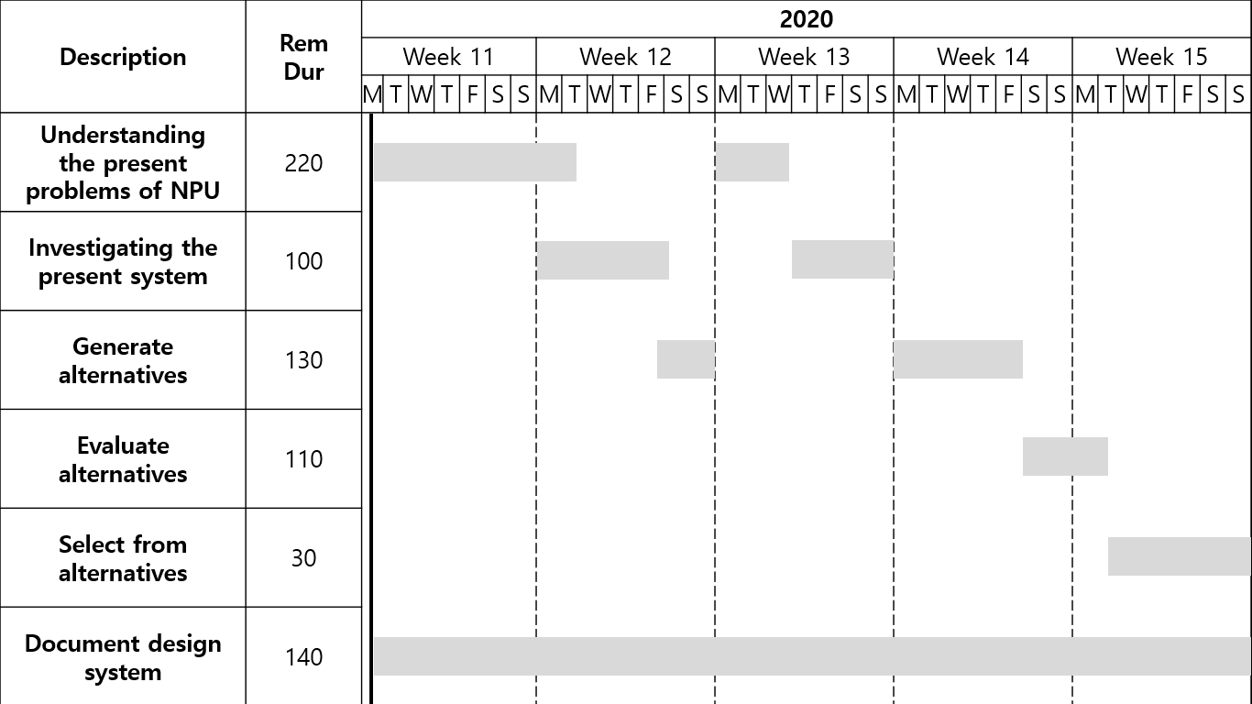

**B. Define principal functions, Constraints, and Objectives tree**

i) Principal functions

* Supporting negative pressure

The function of keeping negative pressure should be working in a revised room.

* Fully managed by medical staffs
* Enabling interactions with others

ii) Constraints

* One medical staff is needed to manage 4~5 patients.
* One to two activities for the patients to achieve per day, but not in a row.
* Resting time is needed between activities.

iii) Objectives trees

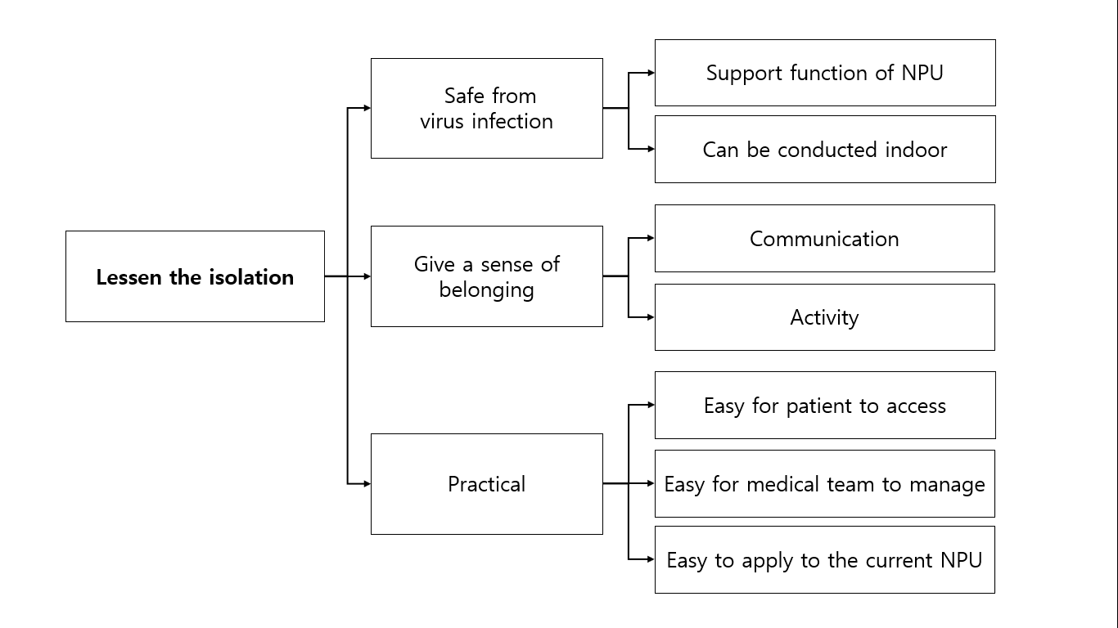

**C. Morphological Chart**

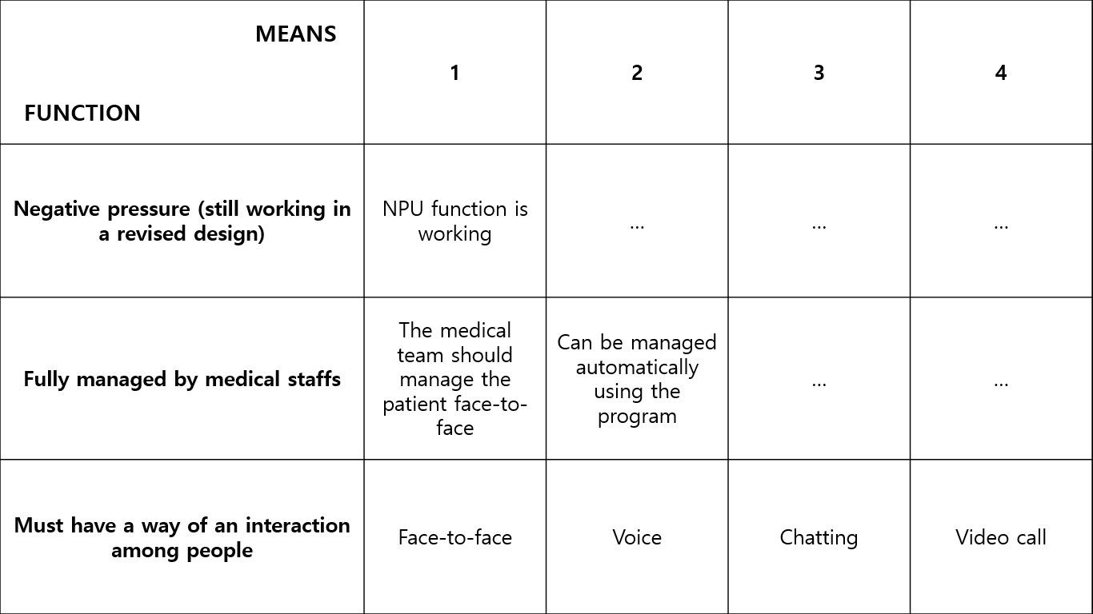

**IV. Research**

A. Researching the present problems of NPU through online documents

B. Researching about the NPU

C. Interviewing with the medical team

D. Reviewing the special lecture

**V. Description and Evaluation of Design Alternatives**

**A. Details and models of alternatives**

i) Team missions via Zoom program

* Details
* Advantages
* Easy to express emotions
* Free from virus infection
* Easy for the medical team to manage
* Disadvantages
* Lack of concentration
* Feel burden on showing own face
* Have constraints on time

ii) Chatting

* Details
* Advantages
* Does not have constraints on time
* Can chat anytime
* Easy to get bond of sympathy
* Disadvantages
* Have difficulties on expressing feelings

iii) Wearing safety suit and meeting

* Details
* Advantages
* Can meet face to face
* Disadvantages
* Has a possibility to get infected
* Have constraints on time
* Need more manpower

**B. Metrics for choosing among the alternatives**

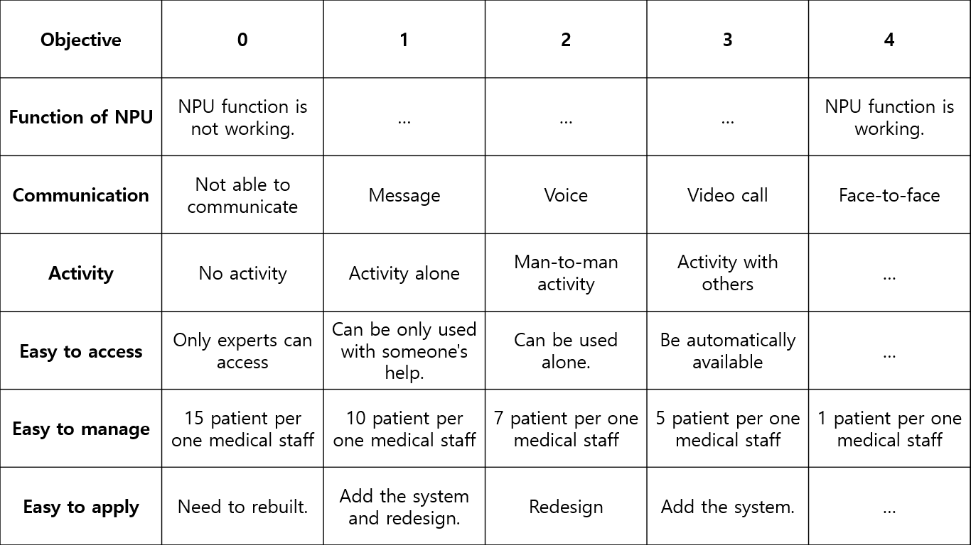

**VI. Final Design**

**A. Detailed Description of chosen alternative**

- **Chatting**

i) Proof of Concept

* Since chatting platforms already exist, it is easy to implement the program. With the basic information that the medical team have about the patients, it is easy to group the patients with similar symptoms.

ii) Design description and specification

* Develop a new messaging platform for quarantined patients around the country.
* All of the patients are grouped into a chatting room with patients with similar. symptoms.
* The permission for entering a particular chatting room is given only by the medical team. One of the most important rule is that people from outside are not allowed to enter the chatting room. Some of the medical teams should be joining in the chatting room to manage unexpected situations.

iii)

**B. Description of predicted outcome of chosen alternative**

i) Design description and specification

**VII. Design Evaluation**

A. Consider of constraints

B. How well design meets objectives

C. How can this design can get better

**VIII. Works Cited**

<http://www.donga.com/news/article/all/20200224/99838118/1>